**SANCHEZ INNOCENCIA D**

**MSC DECISION AND COMPUTING SCIENCES**

**Problem Statement 2: (Mandatory)**

**PROBLEM STATEMENT 1: - MANDATORY**

**Explore whether the no. of cases, deaths, CFR … of malaria increases every year.**

**DATASET**

**Three files were given**

1. **Reported Numbers:** Reported number of cases from year 2000-2017

2. **Estimated Numbers:** Estimated number of cases, the ones including reported cases and non-reported cases from year 2010-2017

3. **Incidence per 1000 people:** Number of positive cases amongst per 1000 people of a place

**ALGORITHM: EXPLORATORY DATA ANALYSIS**

**In statistics, exploratory data analysis is the approach which is used to analyse the dataset and summarize its main features, often using statistical graphics and other data visualization methods. A statistical model can be used or not, but primarily EDA is for seeing what the data can tell us beyond the formal modelling or hypothesis testing task.**

**OUTPUT:**

**1. Reported data**

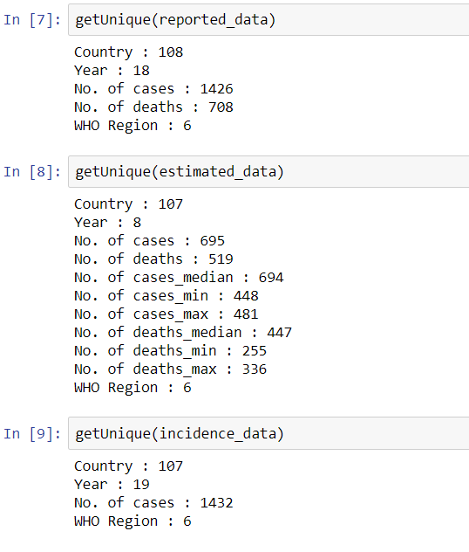

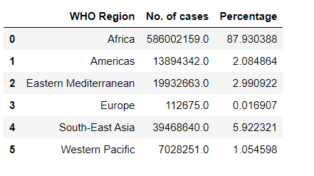

Here we can see that AFRICA constitutes 88% of the reported data. This means, if we include this, most of our data would be biased, so let’s do the analysis in two groups, one includes AFRICA, and one excludes AFRICA

This gives us the trend that, cases are increasing yearly in Africa, whereas, it is declining for the other Regions.

**2. Estimated data**



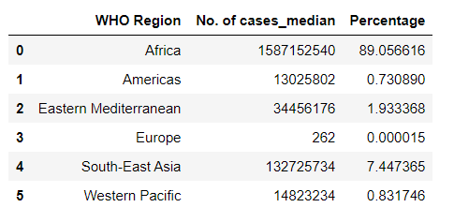

Again, Africa holds 89% of the estimated data.

The estimated data shows a stagnant number of increases in cases, not much. Whereas for the other regions, it is declining.

**3. Incidence data**



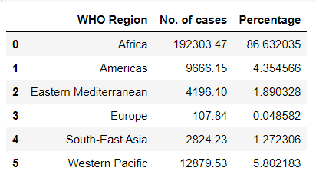

Even for the Incidence data, Africa holds 87% data of cases.

From this, we find that the trends show that the numbers are declining for both. Its small yearly decrease for Africa region, whereas, for other regions, it's a good yearly decrease.

**GRAPHICAL REPRESENTATION**

1. **Reported Data**

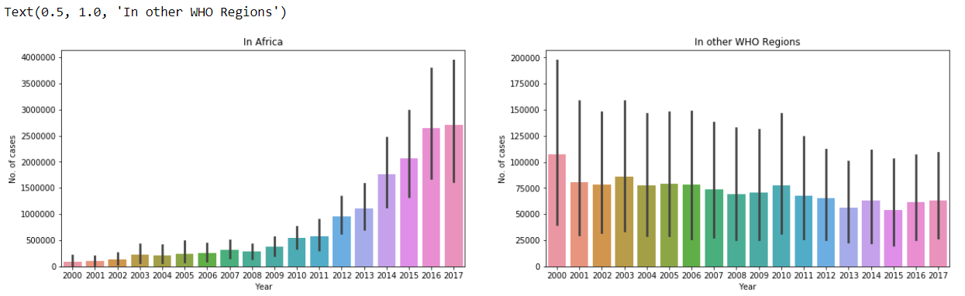

1. **Estimated Data**

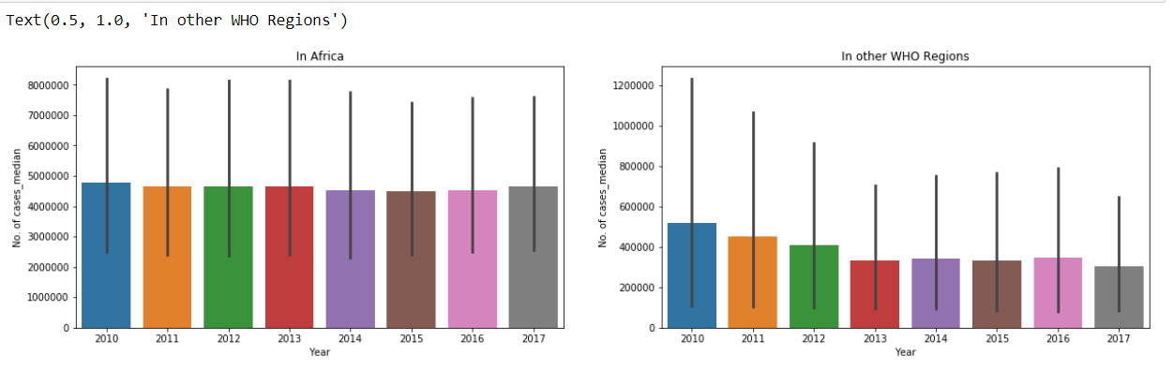

1. **Incidence Data**

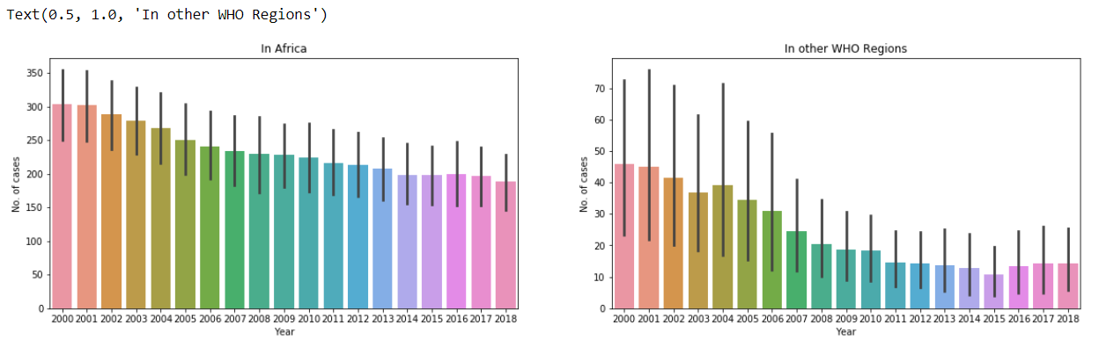

Observing the graphs, the following conclusions can be drawn for all the regions, except Africa, the cases are declining yearly. Africa shows a steady decrease, but not a huge decrease.